21 CleaningData Video Lecture – Reading From MySQL

**MySQL**

1. popular open source database software
2. widely used for internet apps
3. Data are structured in
   1. databases
      1. tables within databases
         1. fields within tables (think of it as a column)
4. Each row is called a “record”

**Example Structure for MySQL**

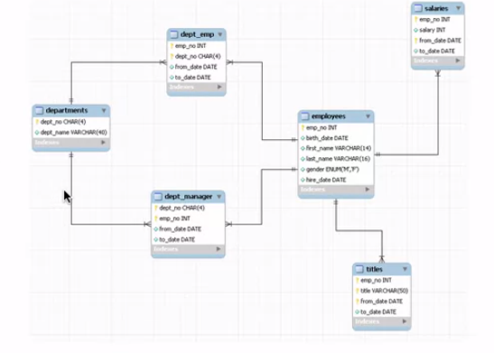

Each blue header is a table/data frame

each line in the table are column names

The common IDs are linked tables and are shown by keys

**Example: UCSC Database**

UCSC Genome Bioinformatics database: https://genome.ucsc.edu/goldenPath/help/mysql.html

username = genomep

password = password

MySQL in R

library(RMySQL)

dbConnect() **connects to the db

dbListTables() **lists all tables(dataframe) in an open MySQL connection

dbGetQuery(connection_name, “SQL Query;”); **write in MySQL syntax, Queries the db connection

dbDisconnect(); **disconnects from the db

dbListFields(db, “table name”) ** lists all column names in the given field

dbGetQuery(db, “select count(*) from table_name”) ** gives back the number of rows

dbReadTable(db, “table_name”) ** reads the table into R as a dataframe

dbClearResult(object); ** clears out the query against the database to save computational time

**Select a subset of a MySQL Query**



